Case 3-Syro Hittite-Double Headed Figure-2500 BCE

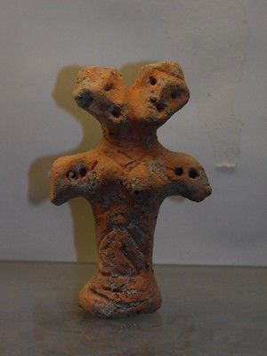

#### [ANCIENT NEOLITHIC CLAY IDOL](http://www.ebay.com/itm/231815202200)

|  |  |
| --- | --- |
| Item price | $222.50 |
| Quantity | 1 |
| Item number | 231815202200 |
| Shipping service | Standard Shipping from outside US |